Day 53 – Specific Gates Using DEMUX

Introduction: A Demultiplexer (DEMUX) is a combinational circuit that routes a single input to one of multiple outputs based on the select lines.

1. XOR Gate Using DEMUX

Design: The XOR gate produces a HIGH output when the two input bits are different. It is implemented by combining the DEMUX outputs corresponding to select combinations 01 and 10.
Boolean Expression: Y = A ⊕ B = A'B + AB' ;
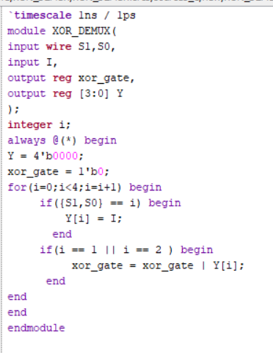

Testbench: The testbench applies all four combinations of select inputs to verify the XOR gate operation with the DEMUX input set to HIGH.

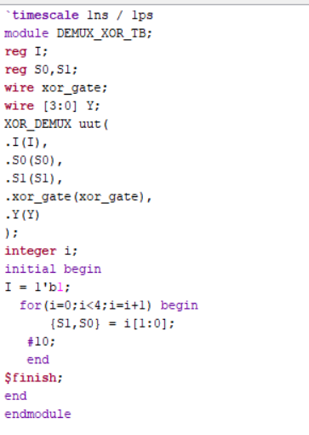

Waveform:The waveform verifies that the XOR output is HIGH when the select inputs are different and LOW when they are the same.

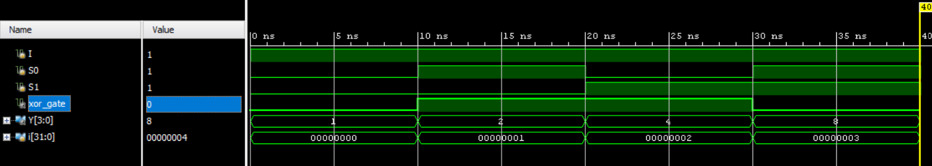

Schematic: The RTL schematic of the XOR gate implemented using DEMUX is generated and analyzed using Xilinx Vivado.

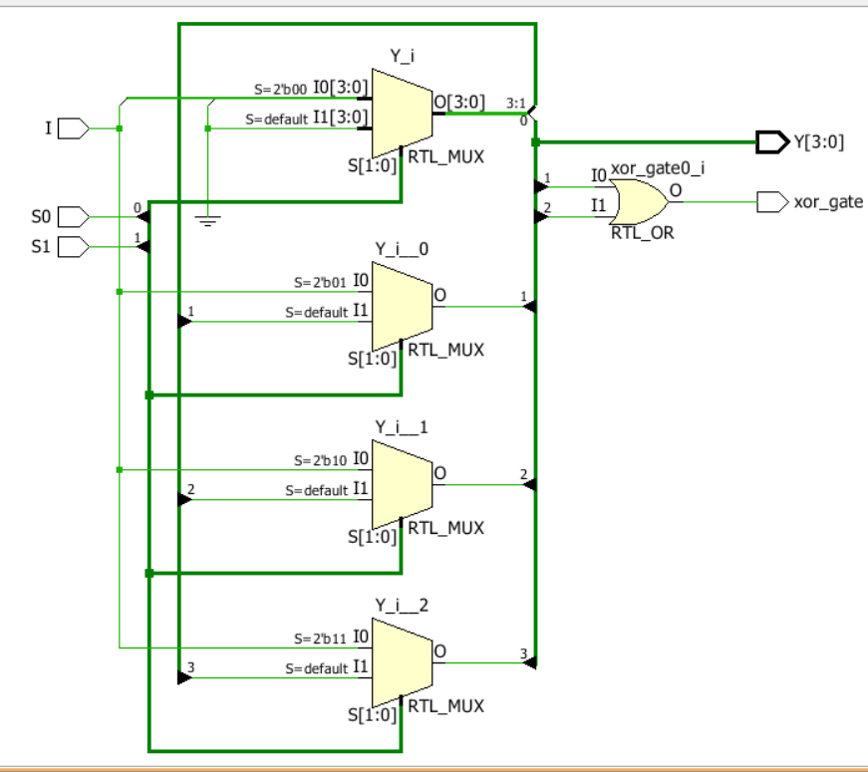

2. XNOR Gate Using DEMUX

Design:The XNOR gate produces a HIGH output when its two inputs are equal. It is implemented by combining the DEMUX outputs corresponding to select combinations 00 and 11.
Boolean Expression: XNOR = (A ⊕ B)' = A'B' + AB
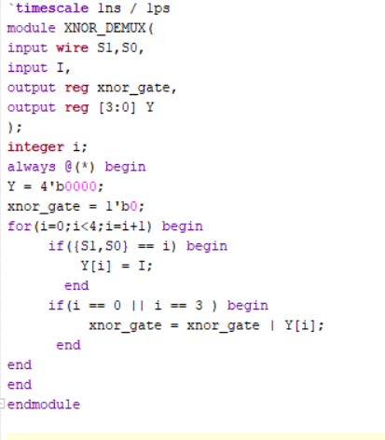

Testbench: The testbench applies all four combinations of select inputs to verify the XNOR gate operation with the DEMUX input set to HIGH.
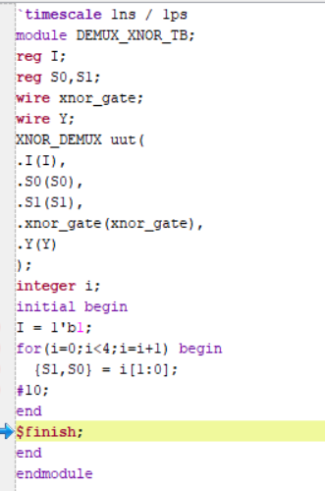

Waveform:
The waveform verifies that the XNOR output is HIGH when the two inputs are equal and LOW when they are different.
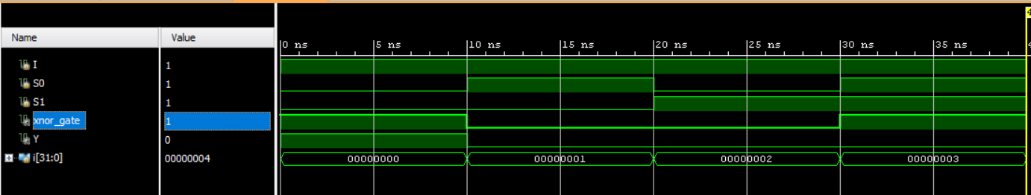

Schematic
The RTL schematic of the XNOR gate implemented using DEMUX is generated and analyzed using Xilinx Vivado.
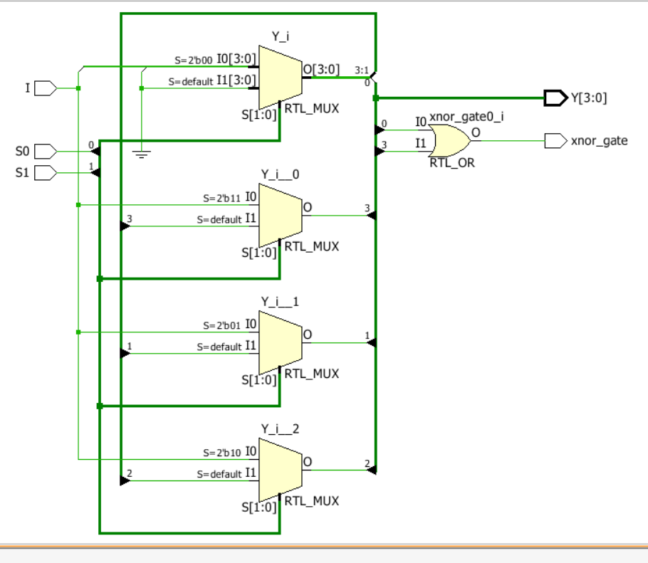

Observation
The XOR and XNOR gates were implemented using DEMUX-based logic and verified through simulation. This experiment improved my understanding of Boolean expressions, DEMUX output selection, and combinational logic design using Verilog HDL.

#PHANEENDRA.SINGUDASU

